**MINI PROJECT-II**

**(2018-19)**

**Textput**

**Software Requirement Specification**



Institute of Engineering & Technology

**Team Members**

Manish Kumar Sharma

161500305

**Mini Project Guide**

Dr.Anand Prakash Gupta

Technical Trainer

Department of Computer & Applications

**Table of Contents**

1.Introduction

1.1 Overview…………………………………………………………...……… 3

1.2 Purpose…………………………………………………………………….. 3

1.3 Scope….…………………………………………………………………… 4

1.4 Definitions, Acronyms and Abbreviation………...…………………...…….4

1.5 Tools Used…………………………………………………………..………4

1.6 Requirements………………………………………………………….…….5

1.7 References………………………………………………………………...…6

2. Overall Description

2.1 Software Interface……...……………………………………………………7

2.2 Hardware Interface………..………………………………………………...7

2.3 Communication Interface……….…………………………………………8

2.4 Constraints………………………………………………………………..…8

3. Specific Requirements

3.1 Data Flow Diagram………………………………………………………….9

3.2 Sequence Diagram…………………………………………………………10

3.3 ER Diagram………………………………………………………………..11

3.4 Use Case Diagram………………………………………………………...12

4.Conclusion…………………………………………………………………12

**1 Introduction**

* 1. **Overview**

We are stuck with technology when what we really want is just stuff that works. With the current paradigm shift in technological field, there is an urgent need to embrace and appreciate the power of technology. Today we know that machines have become smarter than us and can help us with every aspect of life, the technologies have reached to an extent where they can do all the tasks of human beings like household tasks, controlling home devices, making appointments etc.

The field which makes these things happen is Machine Learning. Machine Learning train the machines with some data which makes it capable of acting when tested by the similar type of data. The machines have become capable of understanding human languages using Natural Language Processing.

Today researches are being done in the field of text analytics.  
As the project title suggests, textput is a web-based application which helps in summarizing the text. We can upload our data and this application gives us the summary of that data in as many numbers of lines as we want. The product is mainly a text summarizing using Deep Learning concepts. The main purpose is to provide reliable summaries of web pages or uploaded files depends on the user’s choice. The unnecessary sentences will be discarded to obtain the most important sentences.

**1.2Purpose**

Over the years we were reading such large piece of text and taking lots and lots of time to extract the meaning from the text so, I decided to do make a text summarizer.

Management has become difficult because of issues that include:

i) Data growth:- Data increase day to day. Knowledge of each and every data is difficult and need manpower to extract information.

ii) Lack of time :- There is a lack of time nowadays which makes it difficult to read suck large piece of text and extract meaning.

**1.3 Scope**

The project scope defines the description of the work that is required in delivering the textual summarization. The following are the scopes of work during the course of the project: Study and understand the requirement of this project

Construct Software Requirement Specification document of the system Construct Software Design Document of the system

**1.4** **Definitions, Acronyms and Abbreviations**

Methodology :- The term methodology means the technique and procedure adopted by conducting a research study. It outlines how data will be collected and the tools for collecting data, system methodology, the proposed system input and output, users and systems development tools.

SRS-Software Requirement Specification

OOP-Object Oriented Programming

GUI-Graphics User Interface

DFD-Data Flow Diagram

IEEE-Institute of Electrical &Electronics Engineering

ER Diagram- Entity Relationship Diagram

**1.5 Tools Used**

Django framework

Pycharm

CSV and text file

Beautiful soup Package

API-

1.Gensim Summarizer

2.Vader Sentiments

3.News API

**1.6 Requirements**

**1.6.1 User Requirements**

It entailed user involvement and statements of facts and assumptions that define the expectations of the system in terms of mission objectives, environment, constraints and measures of effectiveness and suitability.

Basically the users:

1. A system that improves on the efficiency of Information storage and retrieval.
2. A system that is easy to learn and use
3. A system that is fast in processing text
4. A system that is flexible and convenient

**1.6.2 Functional Requirements**

This is a necessary task, action or activity that was accomplished.

The proposed system is able to:

1. Allow administrator to add a new CSV file.
2. Library used beautiful soup for web scraping.

**1.6.3 Hardware Requirement**

i) Processor 1.5 Ghz processor speed

ii) Memory 2GB RAM

iii) Visual Display Unit 800*600 colours

**1.6.4 Software Requirements**  
 i) Operating System- windows 7 or upper

ii) Microsoft Office Power point- Used during presentation

**1.7 References**

[1]https://medium.com/jatana/unsupervised-text-summarization-using-sentence-embeddings-adb15ce83db1

[2] https://towardsdatascience.com/a-quick-introduction-to-text-summarization-in-machine-learning-3d27ccf18a9f

[3]https://www.analyticsvidhya.com/blog/2018/11/introduction-text-summarization-textrank-python/

[4]<https://en.wikipedia.org/wiki/Automatic_summarization>

[5] https://www.geeksforgeeks.org/project-idea-text-summarizer/

**2. Overall Description**

**2.1 Software Interface**

Client on Internet :- Web Browser , Operating System

Client on Intranet :- Web Browser , Operating System

Web Server :- Django server , Operating System(android)

Development End :- Python , Django ,Bootstrap (HTML ,CSS and JavaScript)

**2.3 Hardware Interface**

Minimum requirement :-

* 256MB of RAM or 512MB (minimum)
* 1GHZ processor
* Web browser :-Internet explorer 11, Google Chrome version-4.0 ,safari 9 etc.
* Operating systems which has these web browser.
* Memory 500MB

Recommended Requirements:-

* 2GB or above recommended(4GB)
* 2GHZ processor
* Web browser :- Google chrome 4.0 or above , IE 11 or above etc.
* Operating system any
* Memory 1GB or above

**2.3 Communication Interface:**

* Client(System user) on Internet will be using GET/POST request
* Client(System user) on Internet will be using HTTP/HTTPS protocol.

**2.4 Constraints**

* GUI is only in English.
* Text summarization only in English language.
* URL must be properly given.
* Summarized text will be minimum 50 words.

**3. Specific Requirements**

**3.1 Data Flow Diagram**

Level 0

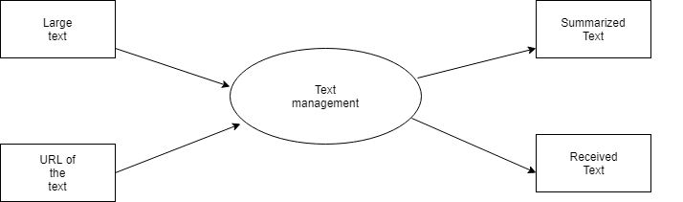

**Level 1** 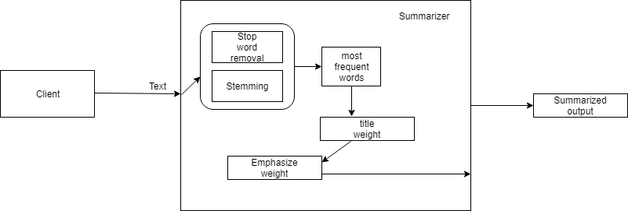

**3.2 Sequence Diagram**

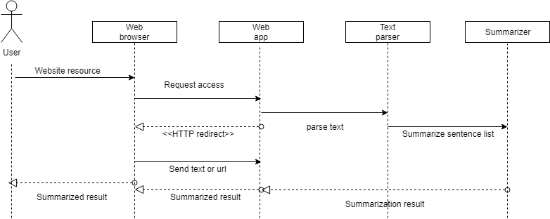

**3.3 ER Diagram:-**

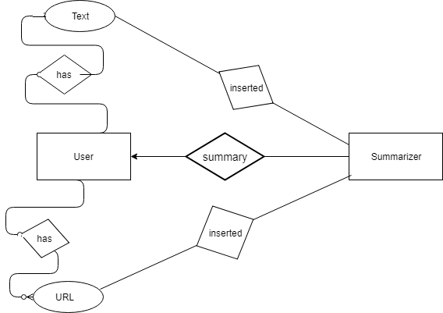

**3.4 Use Case Diagram:-**

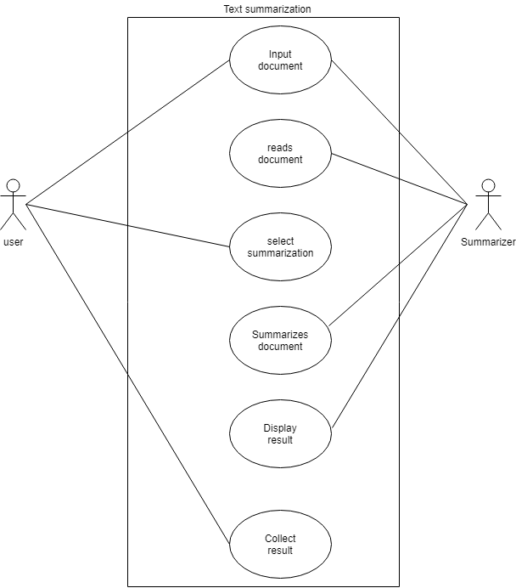

**4 Conclusion**

In conclusion, the software can be used as an inventory system to provide a relevant platform for text summarization.